**WILLIAM SHAKESPEARE**

William Shakespeare was a poet and a playwright, and is widely regarded as the greatest writer in the English language. He was born in Stratford-upon-Avon, in central England, in 1564 and he died in 1616. His surviving work consists of 38 plays, 154 sonnets (a special type of poem with 14 lines), and some other poems. He is best known for his plays, which have been translated into every major language and are performed more than those of any other playwright in the world.

When William Shakespeare was 18 years old he married Anne Hathaway, and they had three children. Shakespeare went to London to work as an actor and a writer. In 1599 the Globe Theatre was built in London and it was in this theatre, situated on the banks of the River Thames, that some of Shakespeare's plays were first performed. In 1613, the theatre was destroyed by a fire. However, a modern reconstruction of the theatre was built near the original site in 1997 so even today you can go to the Globe Theatre to see one of Shakespeare's plays.

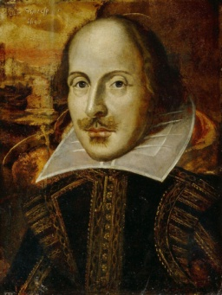

 Taken from: <https://www.teachingenglish.org.uk/language-assistant/essential-uk/shakespeare>

**SONNET 130**

My mistress' eyes are nothing like the sun;   
Coral is far more red than her lips' red;  
If snow be white, why then her breasts are dun;  
If hairs be wires, black wires grow on her head.  
I have seen roses damask'd, red and white,  
But no such roses see I in her cheeks;   
And in some perfumes is there more delight  
Than in the breath that from my mistress reeks.  
I love to hear her speak, yet well I know  
That music hath a far more pleasing sound;  
I grant I never saw a goddess go;  
My mistress, when she walks, treads on the ground:  
   And yet, by heaven, I think my love as rare  
   As any she belied with false compare.